EKS CLUSTER
Go to eks cluster
Click Create eks cluser
Name
Kebernetes version
Iam roles selectet(create role permission AmazonEKSClusterPolicy)
Next click
Vpc,subenet,security group select option

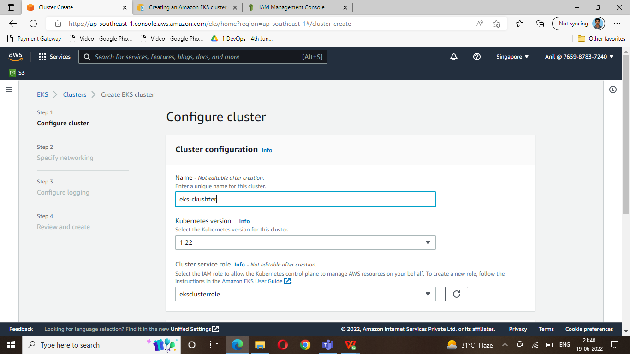

Create eks cluster

2 eks cluster connect git bash terminal
Create one ubuntu server (all traficc security)

Cli installation ubuntu

https://docs.aws.amazon.com/cli/latest/userguide/getting-started-install.html
====
msiexec.exe /i https://awscli.amazonaws.com/AWSCLIV2.msi

iam authenticator
https://docs.aws.amazon.com/eks/latest/userguide/install-aws-iam-authenticator.html
==
2. curl -o aws-iam-authenticator https://s3.us-west-2.amazonaws.com/amazon-eks/1.21.2/2021-07-05/bin/linux/amd64/aws-iam-authenticator

3. chmod +x ./aws-iam-authenticator
4. mkdir -p $HOME/bin && cp ./aws-iam-authenticator $HOME/bin/aws-iam-authenticator && export PATH=$PATH:$HOME/bin

Install kubectl
https://docs.aws.amazon.com/eks/latest/userguide/install-kubectl.html

1.curl -o kubectl https://s3.us-west-2.amazonaws.com/amazon-eks/1.22.6/2022-03-09/bin/linux/amd64/kubectl

2. chmod +x ./kubectl
3. mkdir -p $HOME/bin && cp ./kubectl $HOME/bin/kubectl && export PATH=$PATH:$HOME/bin

Eks to connect

aws eks --region ap-southeast-1 update-kubeconfig --name eks-cluster

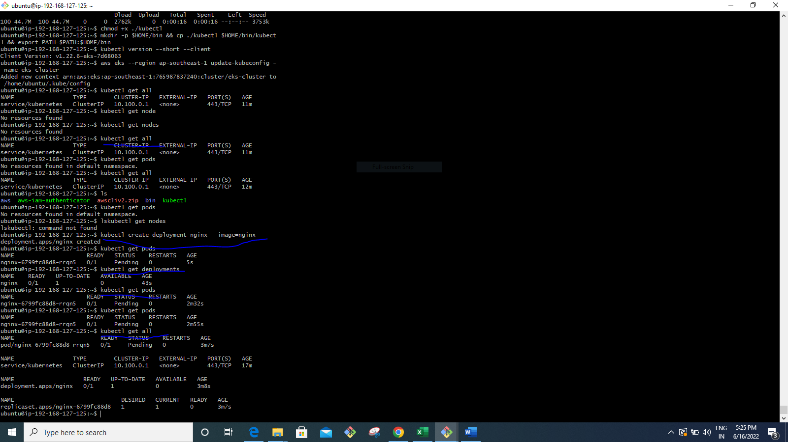

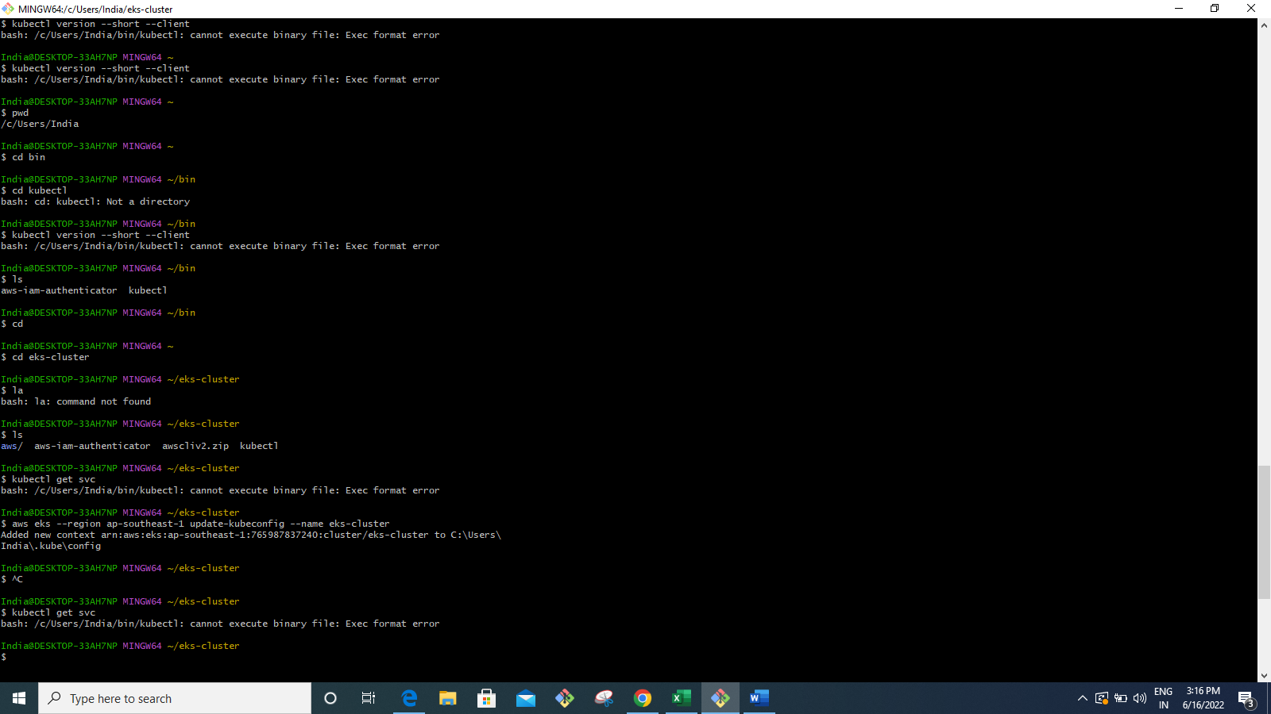

1 curl "https://awscli.amazonaws.com/awscli-exe-linux-x86_64.zip" -o "awscliv2.zip"

2 sudo apt install unzip

3 unzip awscliv2.zip

4 sudo ./aws/install

5 curl -o aws-iam-authenticator https://s3.us-west-2.amazonaws.com/amazon-eks/1.21.2/2021-07-05/bin/linux/amd64/aws-iam-authenticator

6 chmod +x ./aws-iam-authenticator

7 mkdir -p $HOME/bin && cp ./aws-iam-authenticator $HOME/bin/aws-iam-authenticator && export PATH=$PATH:$HOME/bin

8 aws --version

9 aws configure

10 aws s3 ls

11 curl -o kubectl https://s3.us-west-2.amazonaws.com/amazon-eks/1.22.6/2022-03-09/bin/linux/amd64/kubectl

12 chmod +x ./kubectl

13 mkdir -p $HOME/bin && cp ./kubectl $HOME/bin/kubectl && export PATH=$PATH:$HOME/bin

14 ls

15 aws eks --region ap-southeast-1 update-kubeconfig --name eks-cluster

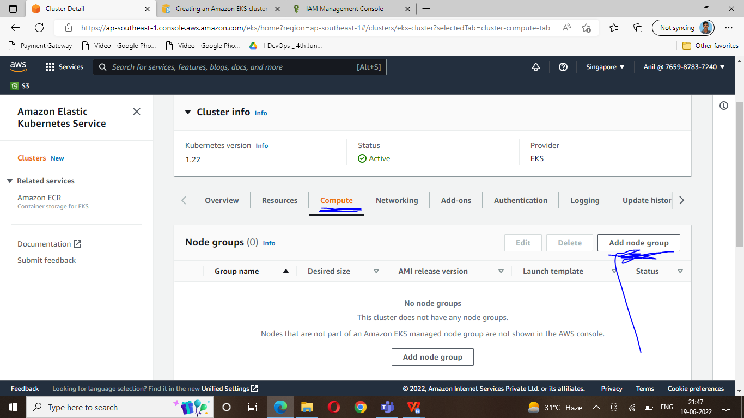

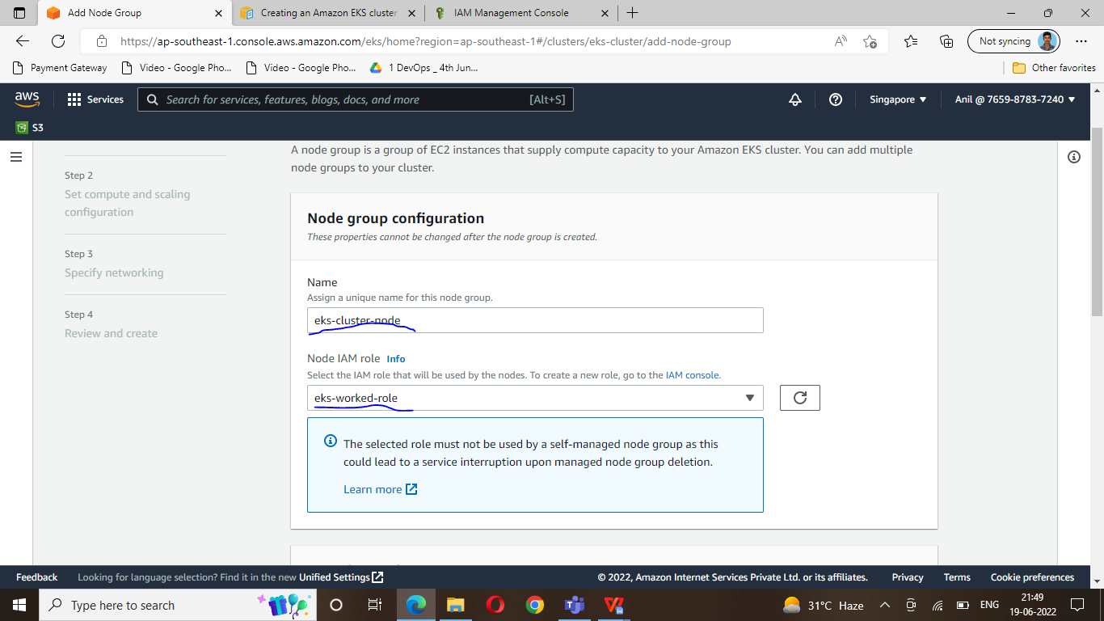

Role (eks-worked-role)

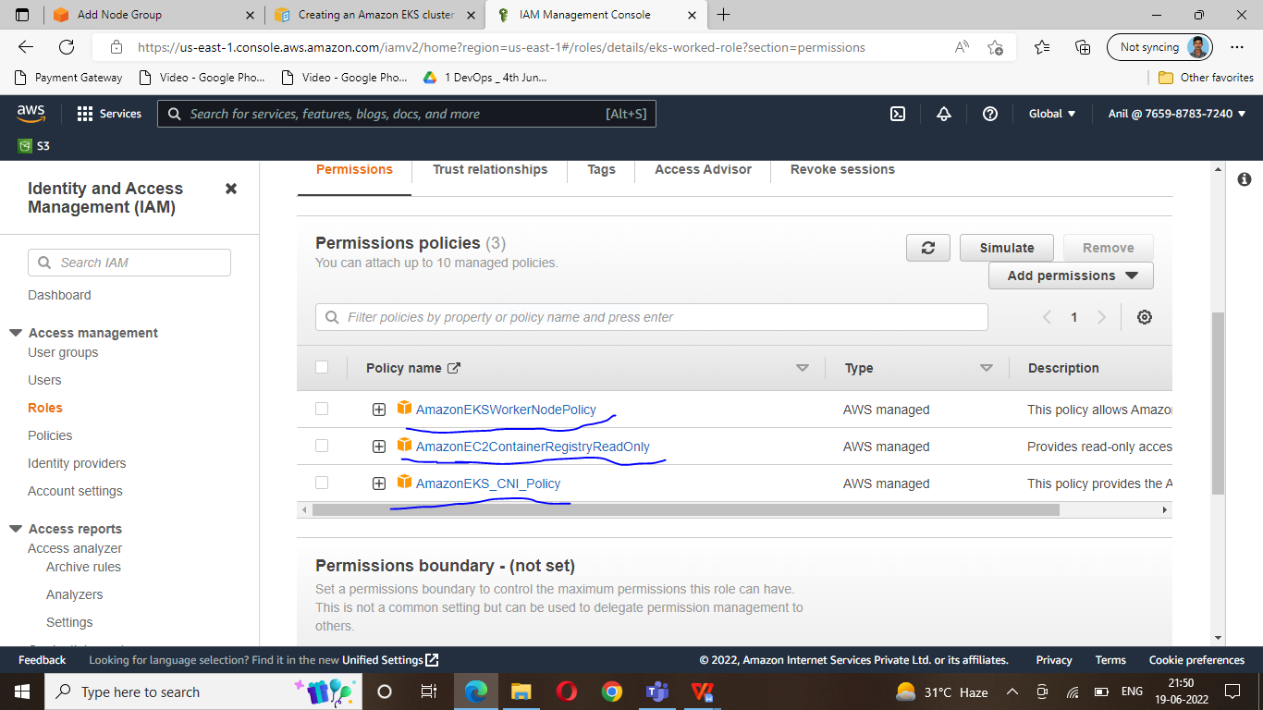

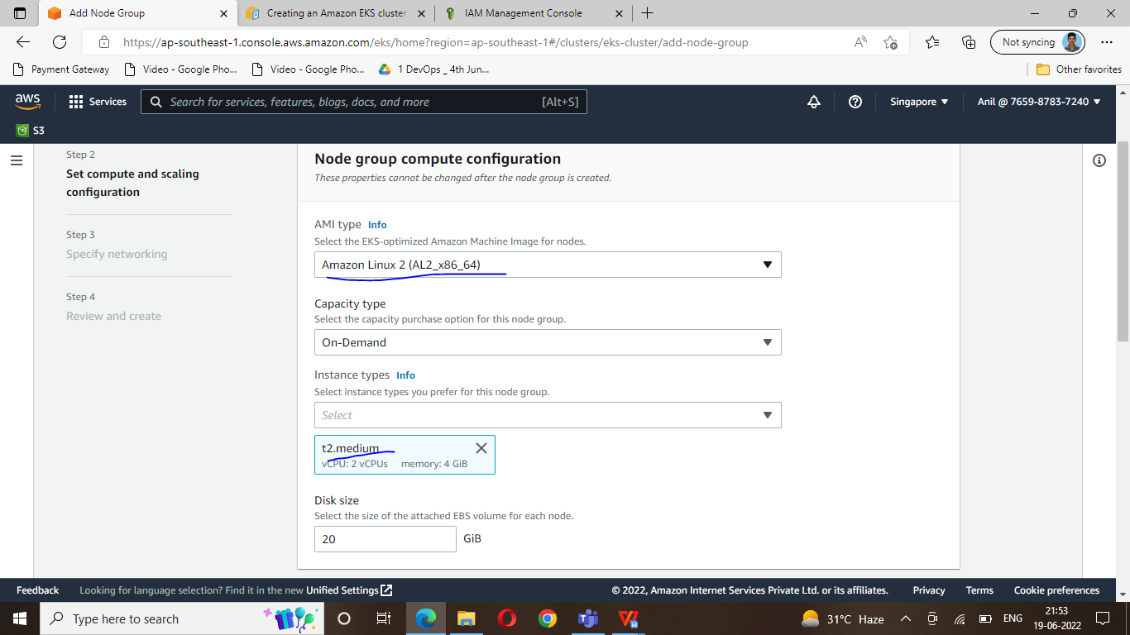
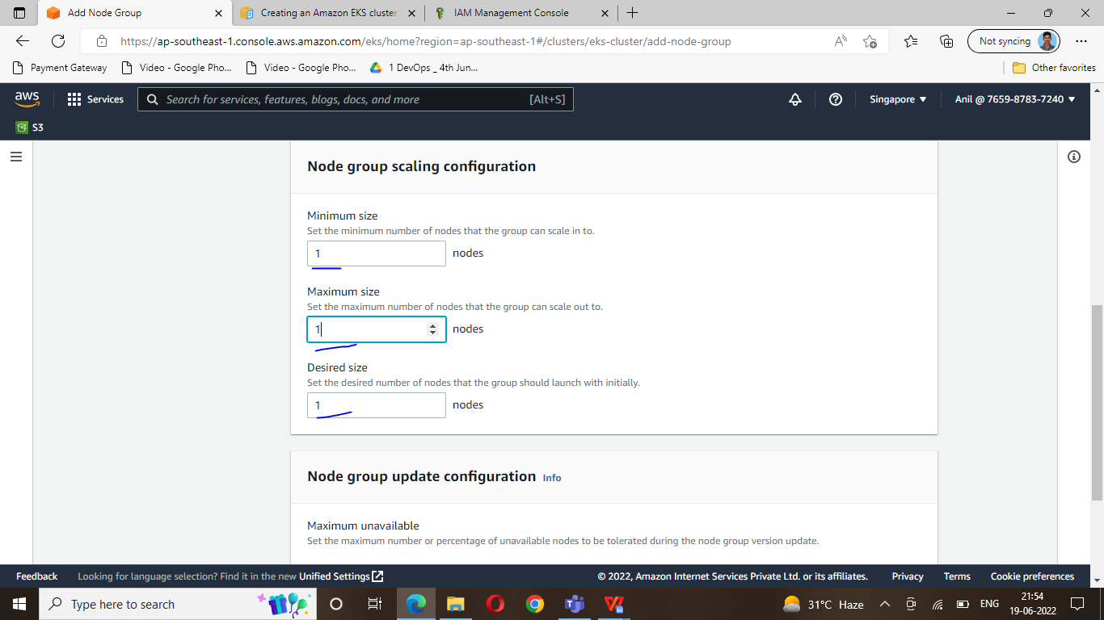

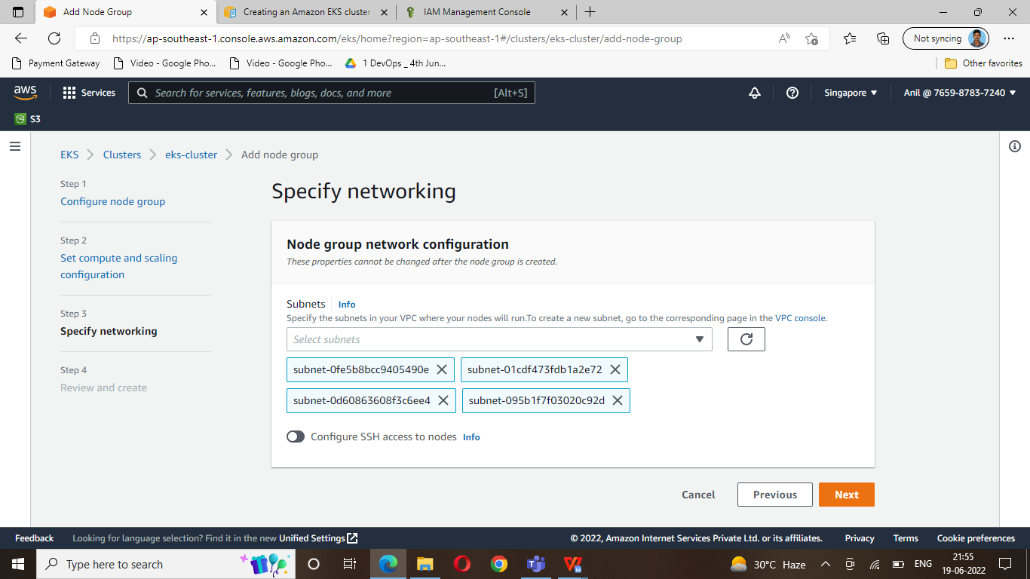
Next click
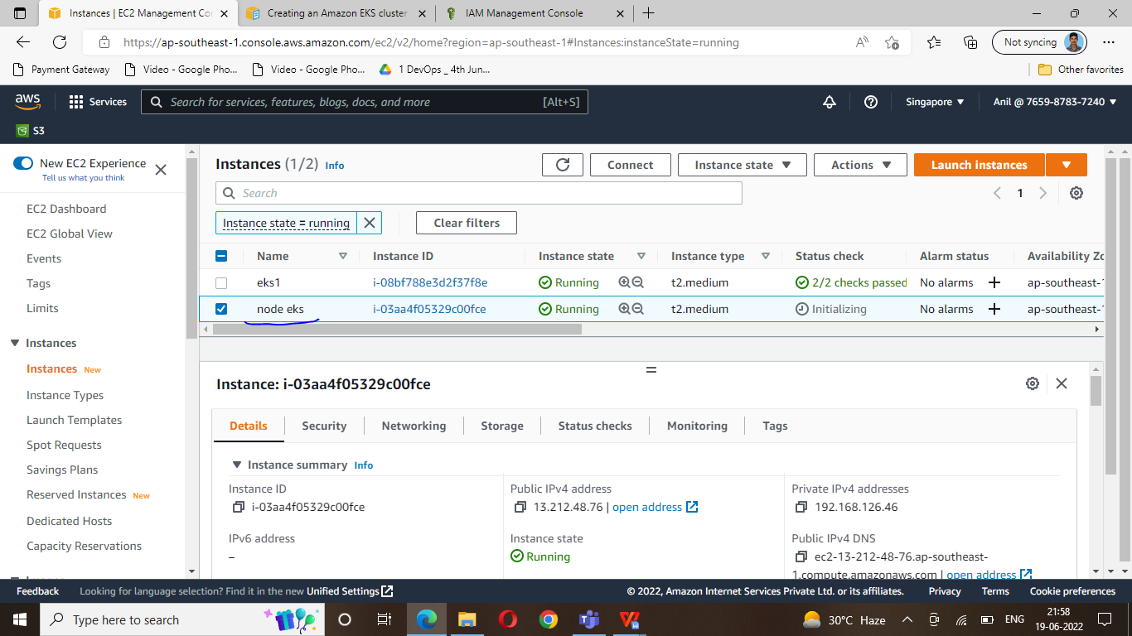

Open master terminal
$ kubectl get all
$ kubect get nodes

Deploy image delete
$ kubectl delete deploy/prometheus-operator

What is kubernetes?
Kubernetes is an open-source container orchestration system for automating software deployment, scaling, and anamgement.
Why is use kubernetes?
If traffic to a container is high, Kubernetes is able to load balance and distribute the network traffic so that the deployment is stable
What is replicatset ?
ReplicaSet is one of the Kubernetes controllers that makes sure we have a specified number of pod replicas running.
What is pod?
A pod is the smallest execution unit in Kubernetes. A pod encapsulates one or more applications.
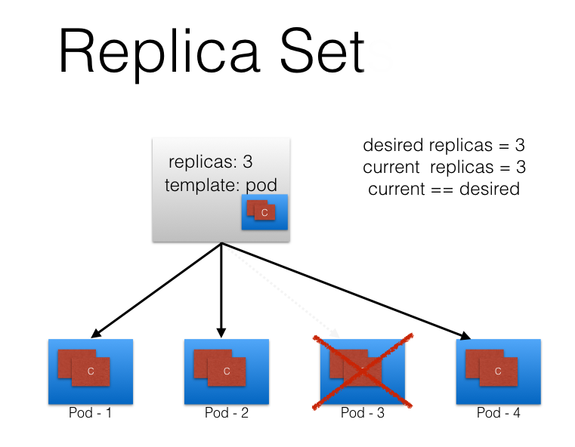

https://www.katacoda.com/
Vi pod.yml
apiVersion: apps/v1
kind: ReplicaSet
metadata:
name: frontend
labels:
app: guestbook
tier: frontend
spec:
# modify replicas according to your case
replicas: 3
selector:
matchLabels:
tier: frontend
template:
metadata:
labels:
tier: frontend
spec:
containers:
- name: php-redis
image: gcr.io/google_samples/gb-frontend:v3

$subectl apply –f pod .yml
$ kubectl get pod

Create nginx

vi nginx.yaml

apiVersion: apps/v1
kind: Deployment
metadata:
name: nginx
spec:
selector:
matchLabels:
run: nginx
replicas: 2
template:
metadata:
labels:
run: nginx
spec:
containers:
- name: nginx
image: nginx:1.7.9
ports:
- containerPort: 80

$ kubectl apply -f nginx.yaml

vi nginx.svs.yaml

apiVersion: v1
kind: Service
metadata:
name: nginx
labels:
run: nginx
spec:
ports:
- port: 80
protocol: TCP
selector:
run: nginx
type: LoadBalancer

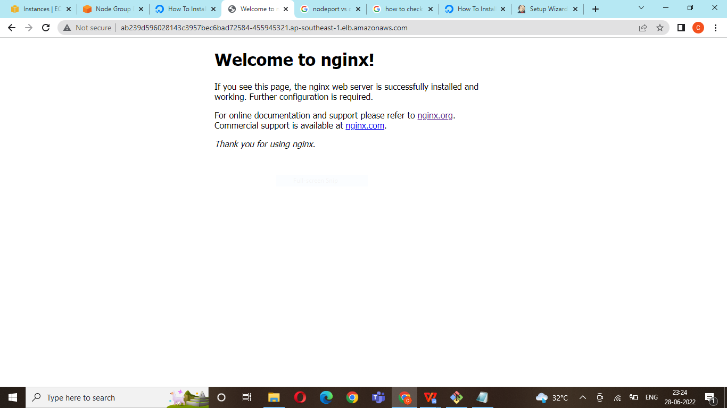

Jenkins installation:

$ kubectl create namespace jenkins

vi jenkins.yaml
apiVersion: apps/v1
kind: Deployment
metadata:
name: jenkins
spec:
replicas: 1
selector:
matchLabels:
app: jenkins
template:
metadata:
labels:
app: jenkins
spec:
containers:
- name: jenkins
image: jenkins/jenkins:lts
ports:
- name: http-port
containerPort: 8080
- name: jnlp-port
containerPort: 50000
volumeMounts:
- name: jenkins-vol
mountPath: /var/jenkins_vol
volumes:
- name: jenkins-vol
emptyDir: {}

$ kubectl apply -f jenkins.yaml

vi jenkins-service.yaml
apiVersion: v1
kind: Service
metadata:
name: jenkins
spec:
type: NodePort
ports:
- port: 8080
targetPort: 8080
nodePort: 30000
selector:
app: jenkins
type: LoadBalancer

---

apiVersion: v1
kind: Service
metadata:
name: jenkins-jnlp
spec:
type: ClusterIP
ports:
- port: 50000
targetPort: 50000
selector:
app: jenkins
type: LoadBalancer

$ kubectl apply -f jenkins-sevice.yaml
$ kubectl get pods
$ kubectl get pods -n jenkins

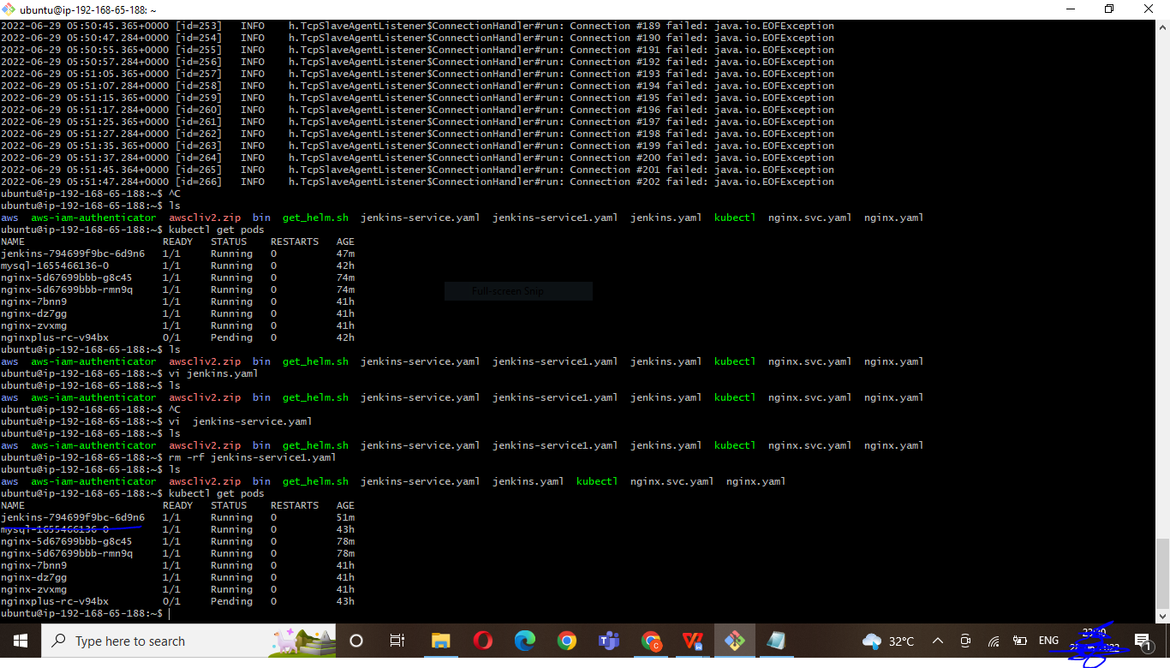

$ Kubectl get svc

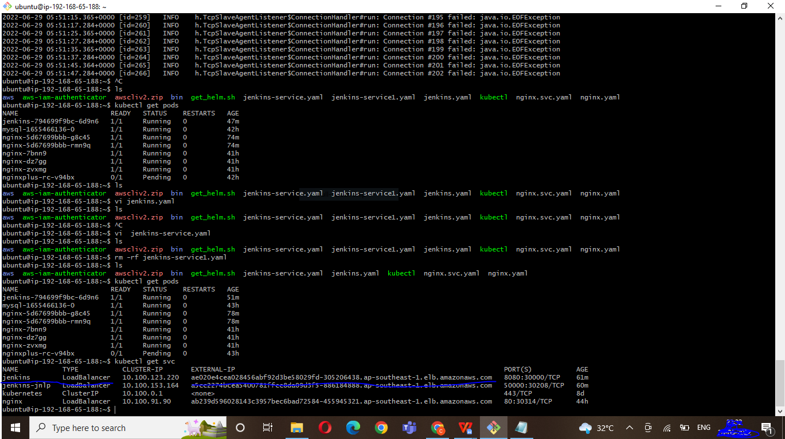

$ kubectl logs jenkins-6fb994cfc5-twnvn -n jenkins (jenkins pod full name) jenkins password

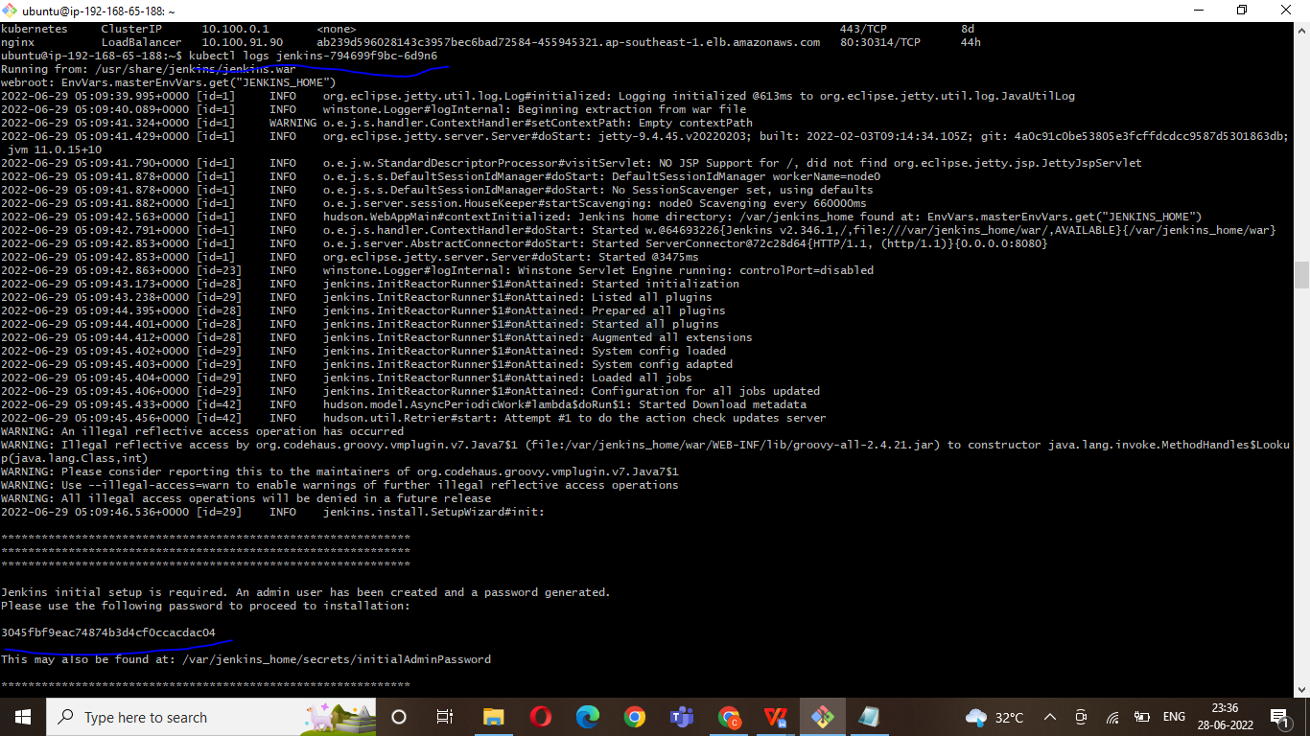

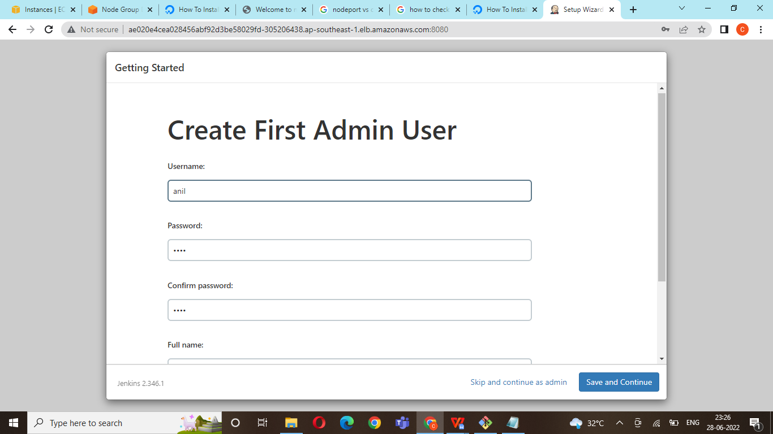

Knote

https://github.com/learnk8s/knote-js/tree/master/

Cloudyeti- eks- webpage

https://github.com/Cloud-Yeti/Cloudyeti-EKS-Series.git

vi deployment-flask.yaml

apiVersion: apps/v1
kind: Deployment
metadata:
name: cloudyeti-flask-deployment
spec:
replicas: 1
selector:
matchLabels:
app: cloudyeti-flask
template:
metadata:
labels:
app: cloudyeti-flask
spec:
containers:
- name: cloudyeti-flask
image: rbngtm1/cloudyeti-flask
ports:
- containerPort: 5000

$ kubectl apply -f deployment-flask.yaml

vi service-flask.yaml

apiVersion: v1
kind: Service
metadata:
name: cloudyeti-flask-service
annotations:
service.beta.kubernetes.io/aws-load-balancer-type: nlb
spec:
type: NodePort
selector:
app: cloudyeti-flask
ports:
- port: 5000
targetPort: 5000
nodePort: 30301
type: LoadBalancer

$ kubectl apply -f service-flask.yaml

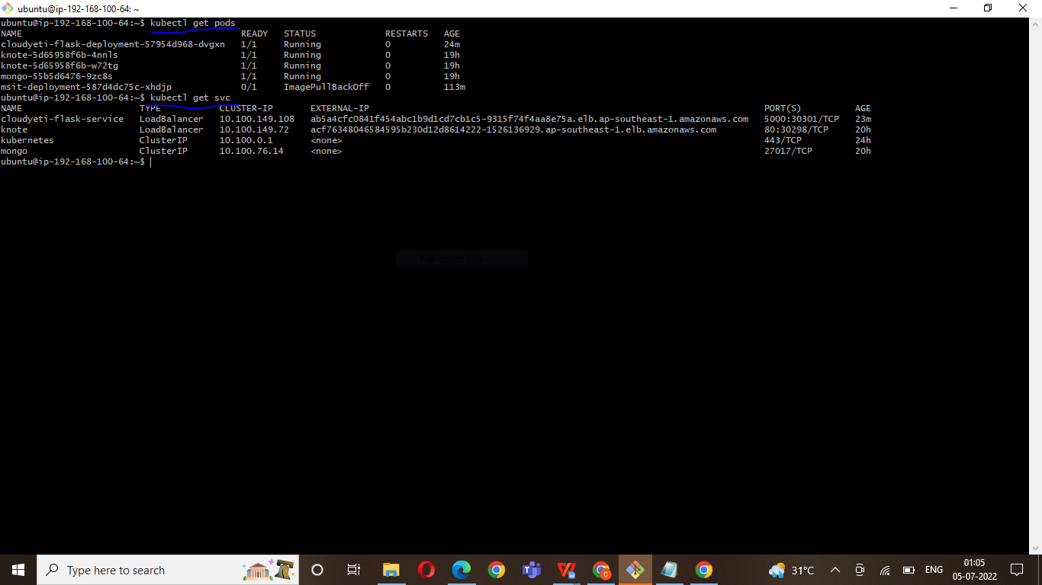

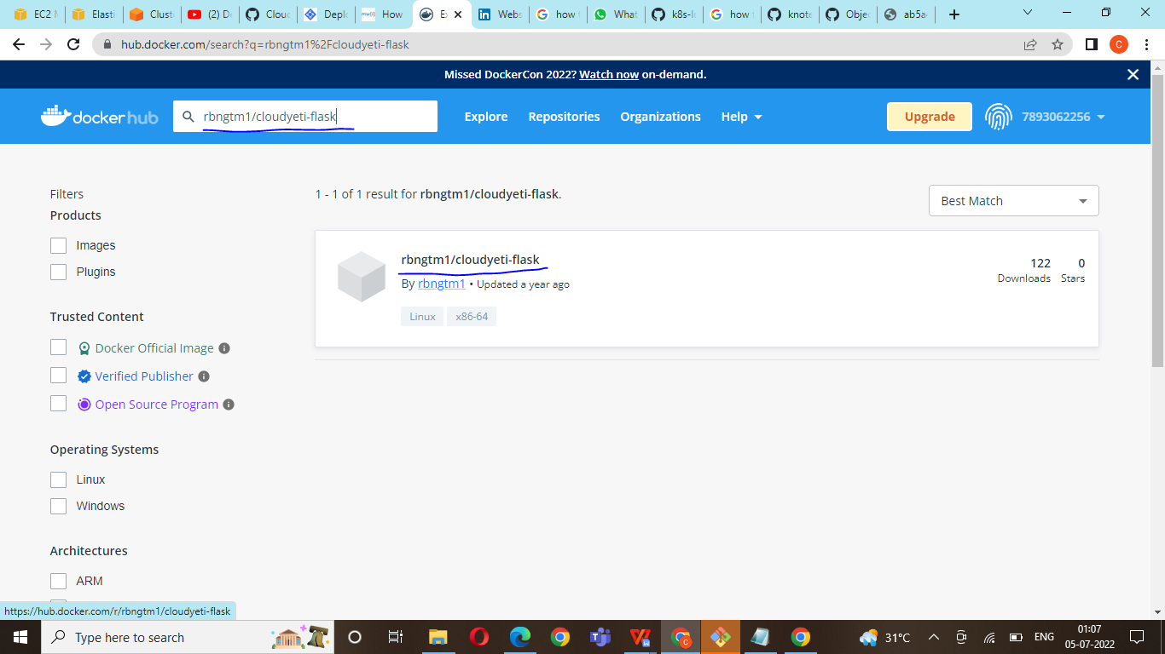

$ Kubectl get svc

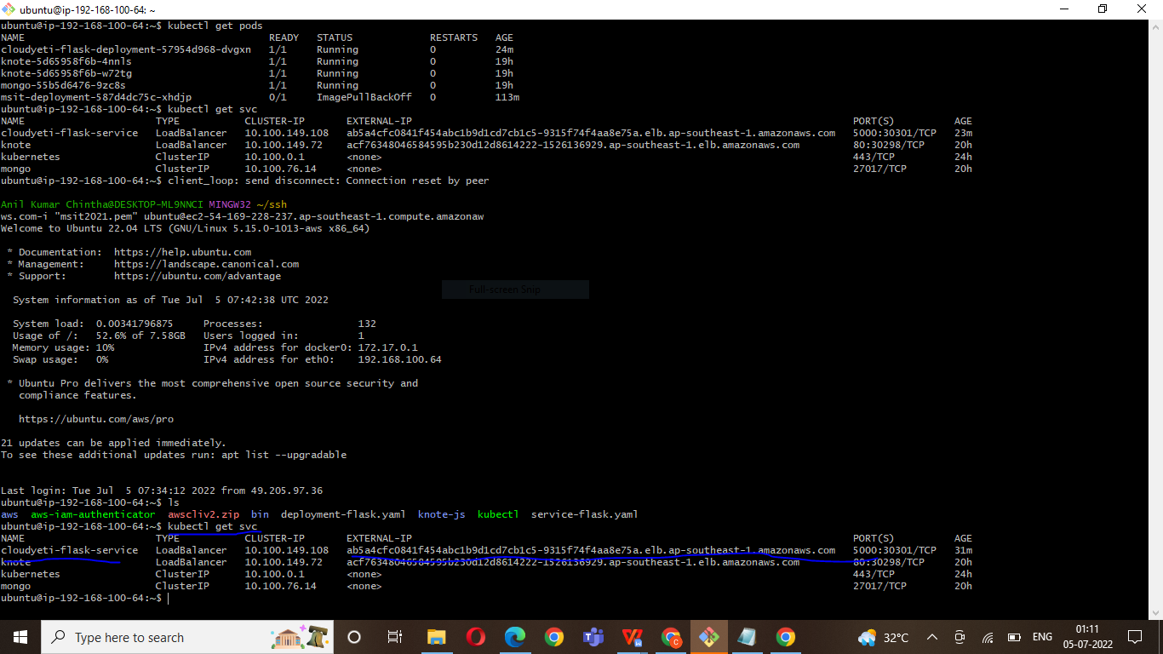

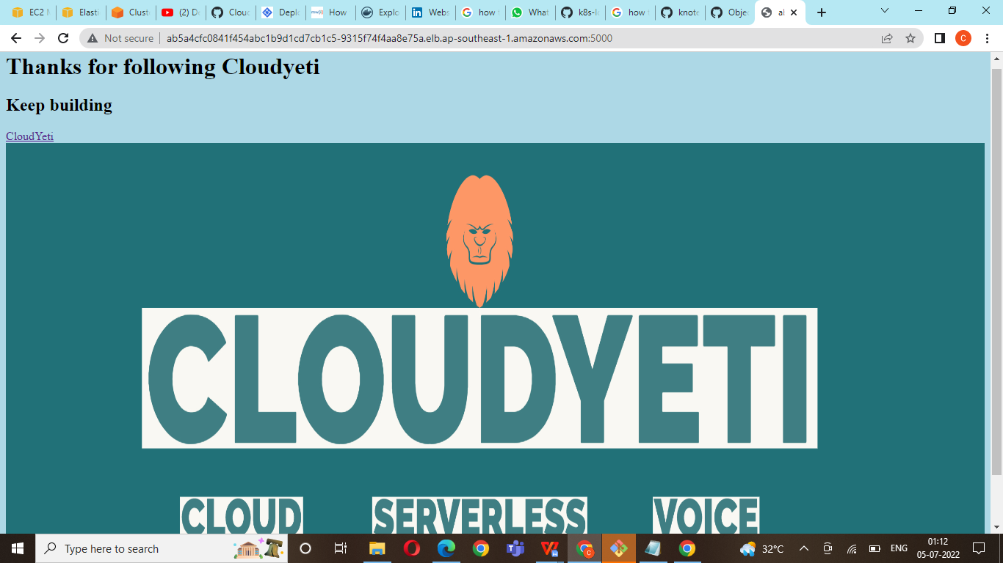

$ kubectl logs cloudyeti-flask-deployment-57954d968-dvgxn

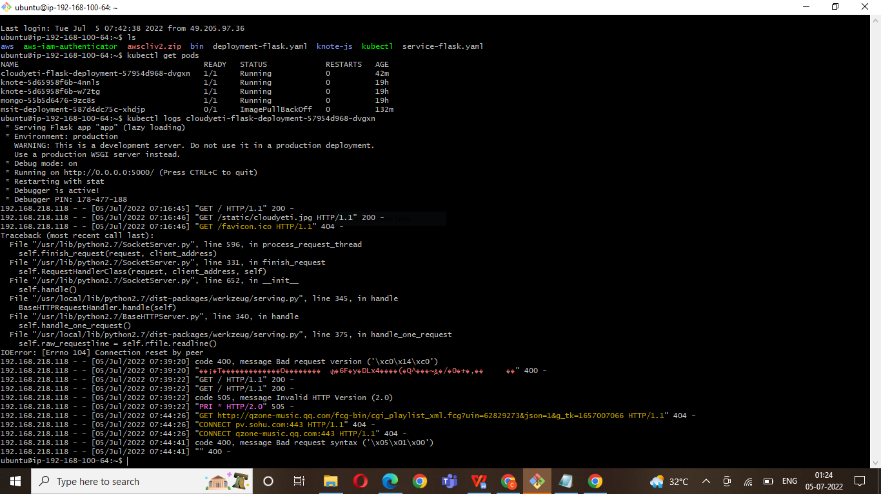

Create a webpage
https://aws.plainenglish.io/how-to-create-an-nginx-docker-image-with-custom-html-and-register-it-with-aws-ecr-cc637bc46d8c

Vi index.yaml
<!DOCTYPE html>
<html lang="en">
<head>
<meta charset="UTF-8" />
<meta name="viewport" content="width=device-width, initial-scale=1.0" />
<meta http-equiv="X-UA-Compatible" content="ie=edge" />
<link rel="stylesheet" href="style.css" />
<title>Login Form Demo</title>
</head>
<head>
<h2 style="color: red;">Welcome to MSIT Solutions</h2>
<p style="color: blue; font-size: 25px; font-style: italic;">One Step Solution to learn technologies in very simple way, Fill the form to sign up.</p>
</head>
<body>
<div class="login-wrapper">
<form action="" class="form">
<h2>Login</h2>
<div class="input-group">
<input type="text" name="loginUser" id="loginUser" required />
<label for="loginUser">User Name</label>
</div>
<div class="input-group">
<input
type="password"
name="loginPassword"
id="loginPassword"
required
/>
<label for="loginPassword">Password</label>
</div>
<input type="submit" value="Login" class="submit-btn" />
</form>
</div>
</body>
</html>

Vi Dockerfile
FROM nginx:latest
COPY ./index.html /usr/share/nginx/html/index.html
WORKDIR /usr/share/nginx/html
RUN date +%x_%H:%M:%S:%N >> ./index.html

$ docker build -t my-nginx .

$ docker images
$ docker run -d -p 8080:80 --name my-nginx my-nginx

- Webpage view:

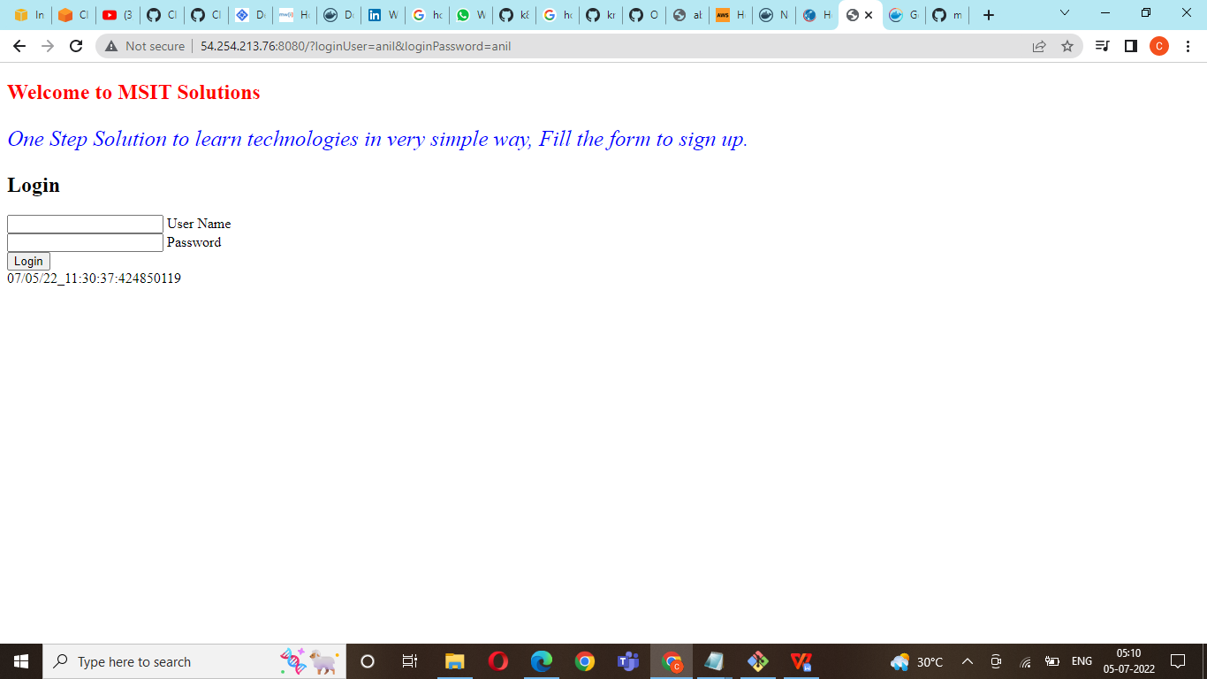

Create a Msit webpage

06/07/2022

https://www.youtube.com/watch?v=ZzGcOos3OCo
Create a index.html file first
Step 1: Connect to Docker Host & Check docker is started
-----------------------------------------------------------------------------------------------
$ service docker status
Step 2: Pull a container Image from Docker Hub
-----------------------------------------------------------------------------
$ docker pull nginx:alpine
Step 3: Inspect the container image
------------------------------------
$ docker inspect nginx:alpine
Step 4: RUN a Docker Container
----------------------------------------------------
$ docker run -d --name happy nginx:alpine
Step 5: Customize the running Container
$ docker cp index.html happy:/usr/share/nginx/html/index.html
Step 6: Create a new image from the running container
----------------------------------------------------------------------------------------
$ docker commit happy 7893062256/msitsolutions (create a docker image name repo)
Step 7: Push the new image to docker hub
----------------------------------------------------------------------
$ docker login
$ docker push 7893062256/msitsolutions (push docker image)

Step 8: Clean the local registry & the container traces
-------------------------------------------------------------------------------------
$ docker stop happy
$ docker rm happy
$ docker rmi nginx:alpine
$ docker rmi 7893062256/msitsolutions

Step 9: Test the New Image
-----------------------------------------------
$ docker run -d -p 8080:80 --name happy 7893062256/msitsolutions

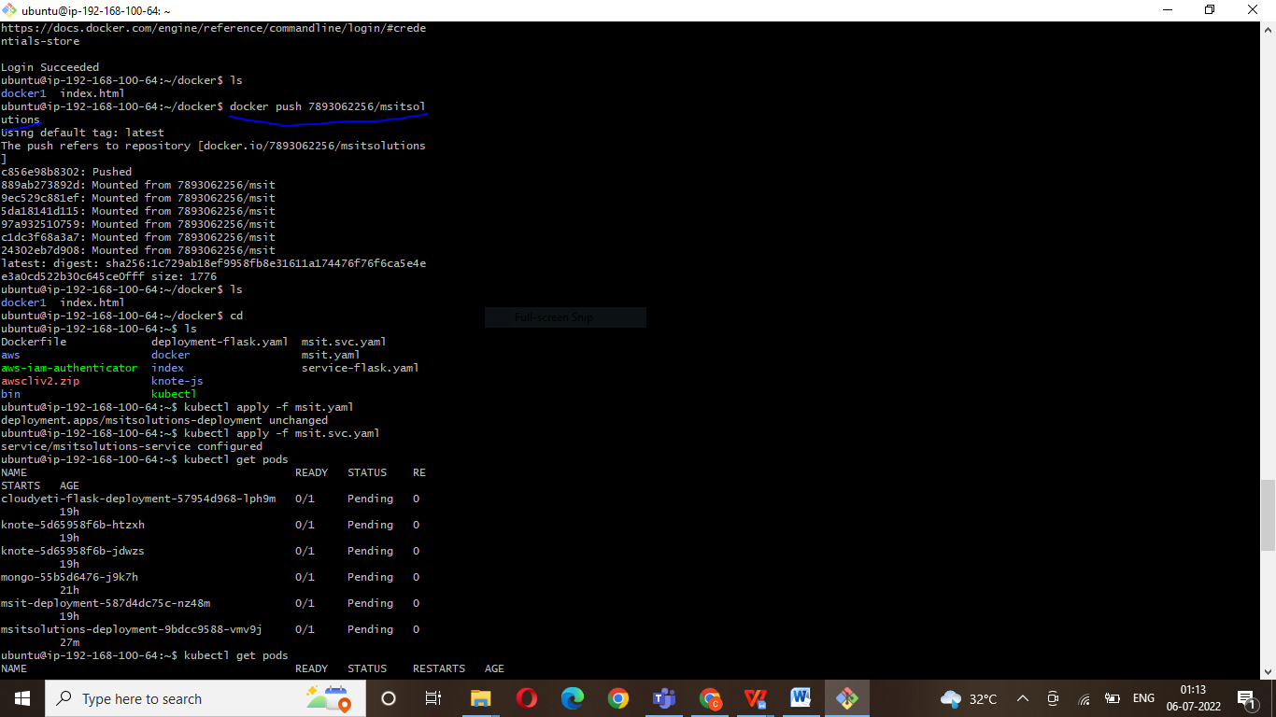
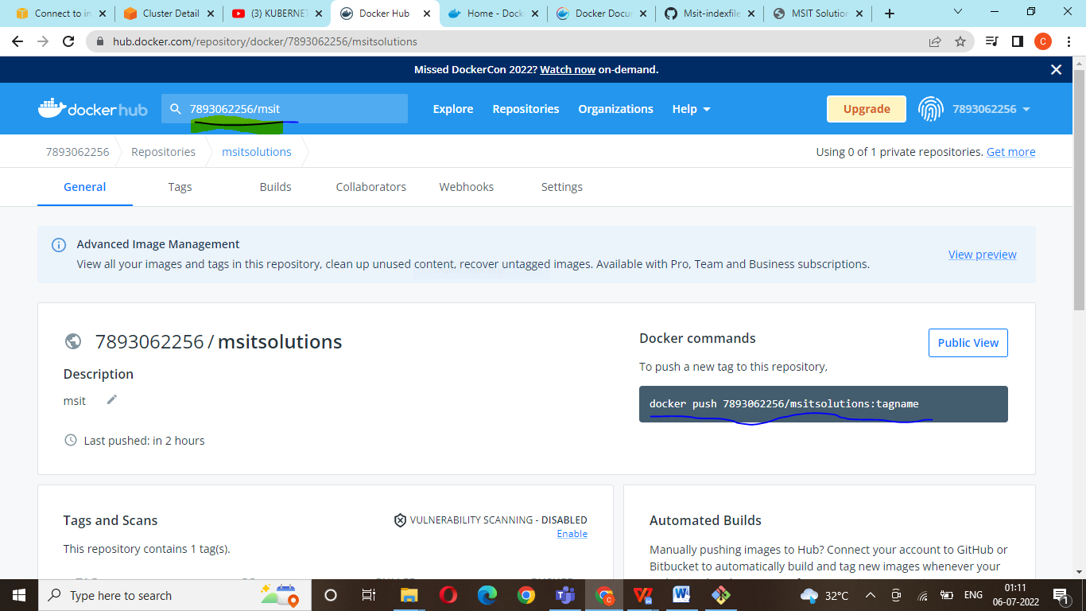

vi msit.yaml
apiVersion: apps/v1
kind: Deployment
metadata:
name: msitsolutions-deployment
spec:
replicas: 1
selector:
matchLabels:
app: msitsolutions
template:
metadata:
labels:
app: msitsolutions
spec:
containers:
- name: msitsolutions
image: 7893062256/msitsolutions
ports:
- containerPort: 5000

$ kubectl apply -f msit.yaml

Create a Service
vi msit.svc.yaml
apiVersion: v1
kind: Service
metadata:
name: msitsolutions-service
annotations:
service.beta.kubernetes.io/aws-load-balancer-type: nlb
spec:
type: NodePort
selector:
app: msitsolutions
ports:
- port: 80
targetPort: 80
nodePort:
type: LoadBalancer
$ kubectl apply -f msit.svc.yaml

$ Kubectl get pods
$ kubectl get svc
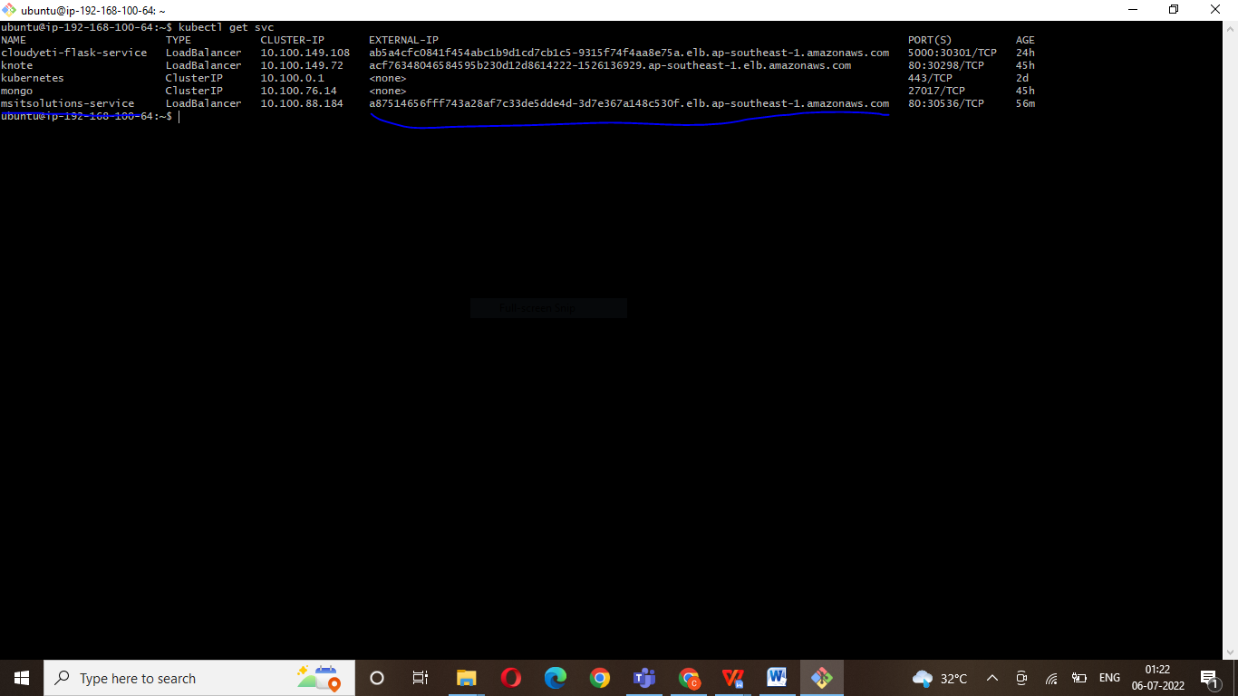

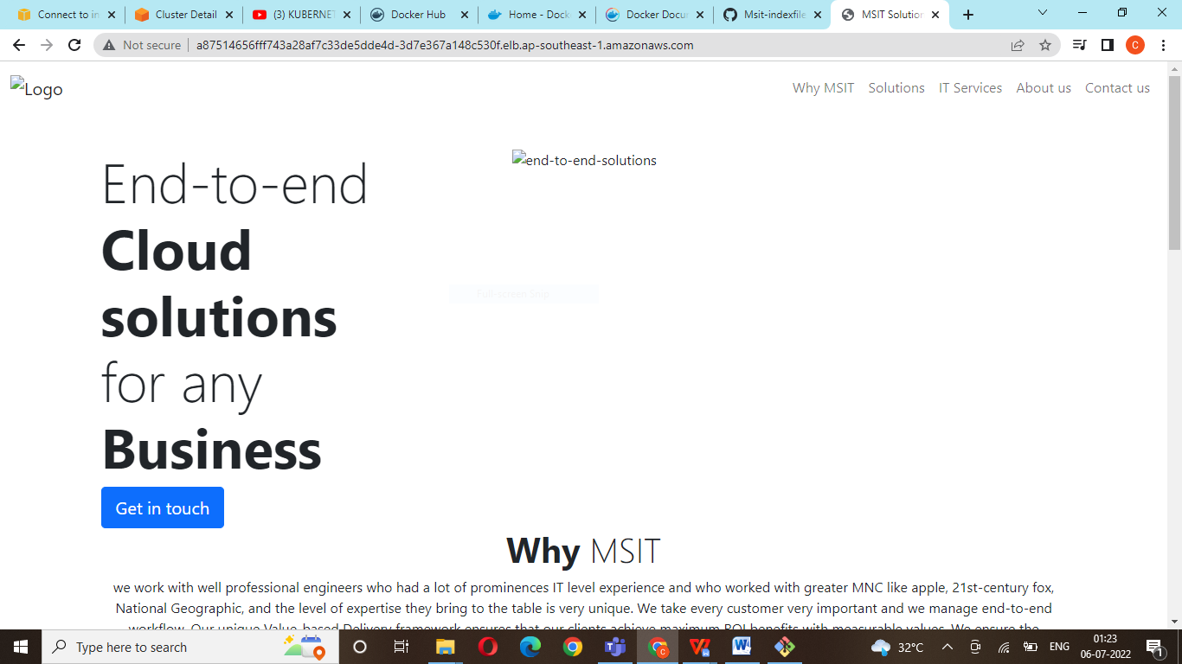

Two application

https://aws.amazon.com/blogs/containers/how-to-expose-multiple-applications-on-amazon-eks-using-a-single-application-load-balancer/

